МІНІСТЕРСТВО ОСВІТИ І НАУКИ УКРАЇНИ
НАЦІОНАЛЬНИЙ УНІВЕРСИТЕТ “ЛЬВІВСЬКА ПОЛІТЕХНІКА”

Кафедра систем штучного інтелекту


Лабораторна робота № 9
з дисципліни «Математичні методи дослідження операцій»

Виконав:
Студент групи КН-215
Лозовий Олег
Викладач:
Шиманський В. М.

Львів – 2023р.
Варіант №2
Тема: Методи умовної оптимізації
Хід роботи:
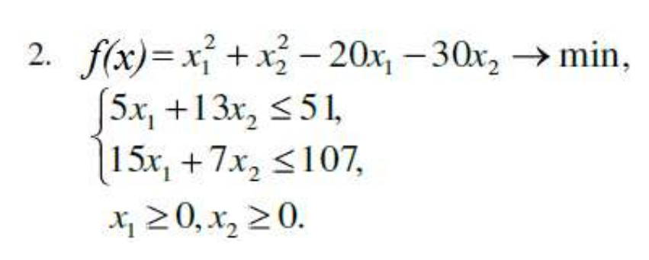

from sympy import *
from sympy.abc import t
from simplex import *
from fibonachi import *
from functions import *
import numpy as np
import math
res_print = true
if g(x1, x2) <= 0 and g1(x1, x2) <= 0:
while mod >= eps:
b1 = np.copy(b)
Fx, Fy = diff(func_f(), x), diff(func_f(), y)
Fx_f, Fy_f = lambdify(x, Fx), lambdify(y, Fy)
x_x0, x_y0 = x - x1, y - x2
cx = Fx_f(x1) * x_x0 + Fy_f(x2) * x_y0
cx_dx, cx_dy = diff(cx, x), diff(cx, y)
c = np.array([cx_dx, cx_dy], dtype=np.float64)
table, b, model = tableu(A, b, c, eq)
vars, cb, res, plan = simplex(model, table, b1)
ans = [0] * 2
# askmax
for i in range(len(vars)):
if int(vars[i] + 1) <= 2:
ans[int(vars[i])] = plan[i]
h_1, h_2 = ans[0] - x1, ans[1] - x2
b_1, b_2 = h_1 * t, h_2 * t
x_1, x_2 = x1 + b_1, x2 + b_2
F_xy_1 = lambdify((x, y), func_f())(x_1, x_2)
F_xy_2 = lambdify(t, F_xy_1)
arg_min = min(fibonacci_method(F_xy_2, eps), 1)
# хk наближення
x_n_1, y_n_1 = x1 + (arg_min * h_1), x2 + (arg_min * h_2)
# похибка
x_x_1, x_x_2 = x1 - x_n_1, x2 - y_n_1
mod = math.sqrt(x_x_1 ** 2 + x_x_2 ** 2)
x1, x2, res = x_n_1, y_n_1, lambdify((x, y), func_f())(x_n_1, y_n_1)
# print(f'=====Iter{k}=====\nx1 = {x1:.10f}\nx2 = {x2:.10f}\nres = {res:.10f}\n\n')
k += 1
else:
print("ineq")
res_print = false
if res_print:
print(f'=====Result=====\nIterations {k}\nx1 = {x1:.15f}\nx2 = {x2:.15f}\nres = {res:.15f}')

simplex.py
import numpy as np
def tableu(A, b, c, eq):
A1, zeroes = [], []
for i in range(len(eq)):
if eq[i] == '>=':
x, b[i] = (-1) * A[i], (-1) * b[i]
A1.append(x)
else:
A1.append(A[i])
zero = [0] * len(eq)
zero[i] = 1
zeroes.append(zero)
zeroes = np.transpose(zeroes)
table = np.hstack((A1, zeroes))
model = [0] * len(table[0])
for i in range(len(c)):
model[i] = c[i]
return table, b, model
def find_basis_variables(A):
A_T = A.T
constraint = np.sum(A_T == 1, axis=1) == 1
constraint &= np.sum(A_T == 0, axis=1) == A_T.shape[1] - 1
indexes = np.where(constraint)[0]
variables_order = np.zeros(len(indexes))
for idx in indexes:
right = np.where(A_T[idx] == 1)
variables_order[right] = idx
return variables_order
def simplex(c, A, b):
basic_variables = find_basis_variables(A)
while True:
cb = np.array([c[int(i)] for i in basic_variables])
dot_product = np.dot(cb, A)
for i in range(len(dot_product)):
dot_product[i] -= c[i]
if np.all(dot_product <= 0):
return basic_variables, cb, np.dot(cb, b.T), b
main_col = np.argmax(dot_product, axis=0)
if np.all(A[:, main_col] <= 0):
print("Нема розв'язку!")
return None
rel = np.zeros_like(b)
np.divide(b, A[:, main_col], out=rel, where=A[:, main_col] > 0)
rel[A[:, main_col] <= 0]
rel1 = np.copy(rel)
for i in range(len(rel1)):
if rel1[i] == 0:
rel1[i] = 1e9
main_row = np.argmin(rel1, axis=0)
pivot = A[main_row][main_col]
old_var, basic_variables[main_row] = int(basic_variables[main_row]), main_col
old_col, b_old = np.copy(A[:, old_var]), np.copy(b)
for i in range(len(b)):
b[i] = (b_old[i] * pivot - b_old[main_row] * A[i][main_col]) / pivot
b[main_row] = b_old[main_row] / pivot
for i in range(len(b)):
for j in range(len(c)):
if i != main_row and j not in basic_variables:
A[i][j] = (pivot * A[i][j] - A[i][main_col] * A[main_row][j]) / pivot
A[main_row] = A[main_row] / pivot
A[:, main_col] = old_col

functions.py
from sympy.abc import x, y
import numpy as np
x1, x2, eps = 0, 0, 1e-3
mod, k = eps * 1e6, 1
A = np.array([[5, 13], [15, 7]], dtype=np.float64)
b = np.array([51, 107], dtype=np.float64)
eq = ["=<", "=<"]
def func(x):
return x[0] ** 2 + x[1] ** 2 - 20 * x[0] - 30 * x[1]
def func_f():
return x ** 2 + y ** 2 - 20 * x - 30 * y
def g(x, y):
return 5 * x + 13 * y - 51
def g1(x, y):
return 15 * x + 7 * y - 107
fibonachi.py
def fibonacci(n):
i, j, c = 1, 1, 1
while (c < n):
k, i = i, j
j = k + i
c += 1
return i
def fibonacci_method(f, eps=1e-6):
a, b, n, k = -1e6, 1e6, 1, 1
while fibonacci(n) <= (b - a) / eps:
n += 1
y = a + fibonacci(n - k - 1) / fibonacci(n - k + 1) * (b - a)
z = a + fibonacci(n - k) / fibonacci(n - k + 1) * (b - a)
while (b - a) > eps:
if f(y) <= f(z):
b, z = z, y
y = a + fibonacci(n - k - 1) / fibonacci(n - k + 1) * (b - a)
else:
a, y = y, z
z = a + fibonacci(n - k) / fibonacci(n - k + 1) * (b - a)
res = (a + b) / 2
k += 1
return res


